Central Florida Fire Institute at Valencia College | October  Sun Mon Tue Wed Thu Fri Sat  1 2 3 4 5  6 7 8 9 10 11 12  13 14 15 16 17 18 19 Course starts  20 21 Intro. Discussion due 22 Clasroom session A 23 Clasroom session B 24 25 Introductory test due 26  27 Test #1 due 28 29 Clasroom session A 30 Clasroom session B 31
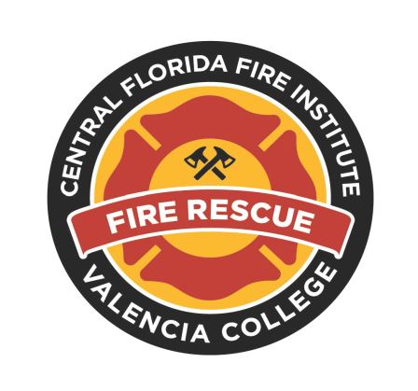  Private Fire Protection Systems I- FFP1540  November  Sun Mon Tue Wed Thu Fri Sat  1 Discussion #1 due 2  3 Test #2 due 4 5 Clasroom session A Practical Exam #1 6 Clasroom session B Practical Exam #1 7 8 9  10 Test #3 due 11 12 Clasroom session A 13 Clasroom session B 14 15 16  17 Test #4 due 18 19 Clasroom session A Practical Exam #2 20 Clasroom session B Practical Exam #2 21 22 23  24 Test #5 due 25 26 Clasroom session A 27 Clasroom session B 28 29 30 | 2013  December  Sun Mon Tue Wed Thu Fri Sat  1 2 3 Clasroom session A Practical Exam #3 4 Clasroom session B Practical Exam #3 5 6 7  8 Test #6 due 9 10 Clasroom session A Practical Exam #4 11 Clasroom session B Practical Exam #4 12 13 Discussion #2 due 14  15 Test #7 Semester ends 16 17 18 19 20 21  22 23 24 25 26 27 28  29 30 31
2013  2010 | 2013

NOTES:

